4. The View.
In the previous sessions we implemented the model part of our series application. We will now make the view and the controller.
The view is the UI part, in this example we look for something like this:
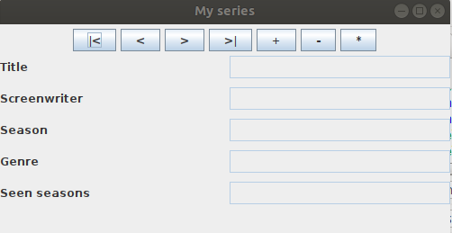

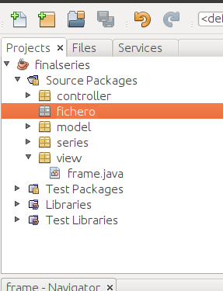
To create a window like the previous one, we will create a new java class in the package view, we will call it frame, and it will be here where we will generate the user interface:

For this we will use three panels, a main one that we will add to the window and with a border type layout. To the north of this, we will put a panel for the buttons and in the central part a panel to visualize the data. The constructor would look like this:

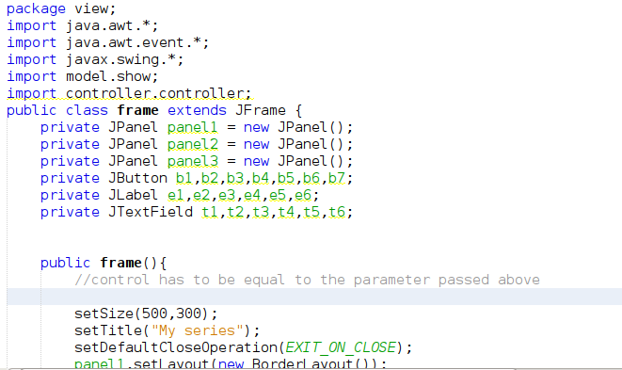

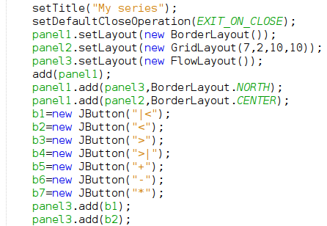

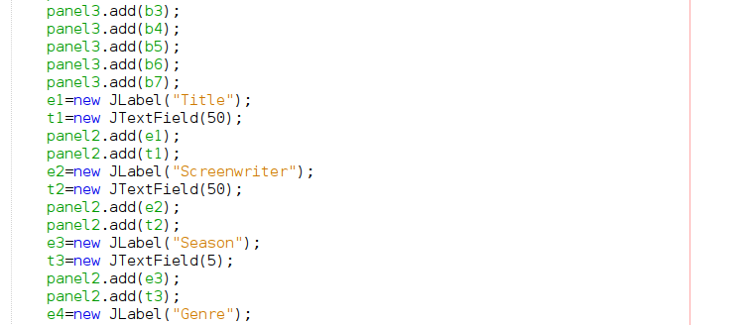
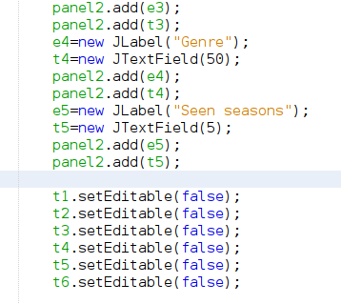

We have added a listener to the buttons and it doesn't exist yet, we created it:
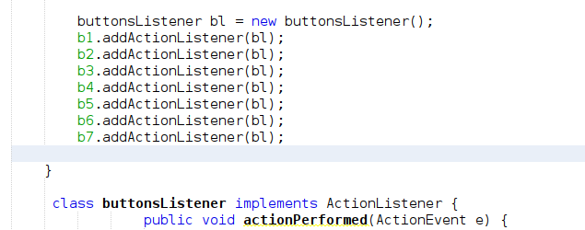

To test that the window fits what we want, we are going to show it in the series package, inside the main of the Series class (the previous code of the main can be commented or deleted, since we put it only to test the model classes):

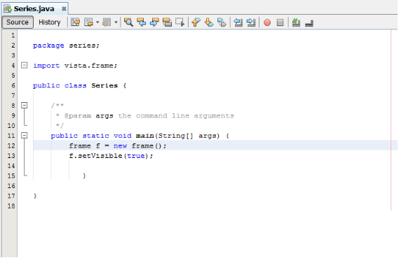

If we execute, the created view should appear:

5. The controller.

The model is the part of the application that communicates the view with the model. It also controls the logic of the application. In a first approach, the controller should have a method to respond to each of the events that the user can cause. In this case, when a user presses any of the buttons, a controller method must be called, we will have at least the following methods:

first → returns the first series.
last → returns the last series.
next → returns the next series.
previous → returns the previous series.
insert → the data of a new series are passed as a parameter and it saves them.
update → the data of a modified series is passed to it as a parameter and it saves it.
delete → the data of a series is passed as a parameter and it deletes it.

In order to carry out all these operations, you must have as property an arraylist of all the series and a variable to establish the position of the series of the arraylist that is currently being displayed. To instantiate an array arraylist you will use the model classes. To make any changes to the series, you will also use the model classes.
In order to have the data of the series that reside in a file when an object of the controller class is instantiated, you must access the file and read the data.
Let's see how all this is in code: we create a new class in the controller package and we also call it controller, in it we will design the controller operations:
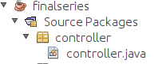

We create the two properties that we will need: position (to point to the current series) and ls that will be an object of the listShow class. In the constructor of the controller class we will have to load in the arraylist of series with the content of the file:
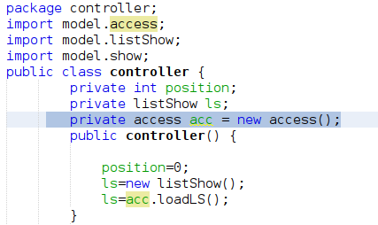

Once we have the constructor, we will implement the method that will respond to the first button of the view, we add it in controller, just after the constructor:
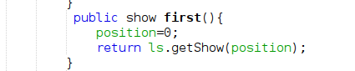

As you can see in the code of the first method, the object of type show (series) that is in the first position of the array arrays ls is returned.
6. Interaction between Vista and Controller.
We have on the one hand the view and on the other the controller, it is necessary to make them work together, so that they communicate with each other. We will make changes to the view and the series.java class that contains the main.
6.1. Necessary changes in the view.
In the Model we have created the method first. We are going to make the necessary code so that when the user clicks the button first, the controller's first method is called and the result can be seen in the JTextField fields. For this we must make some changes in the view, that is, in the frame class:

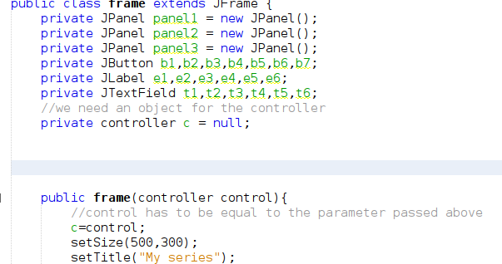

Now we can call the controller's first method from the listener, for this within the frame.java listener we add:

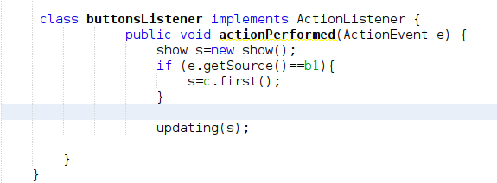

As we have implemented before, the first method of the controller will return the first series through an object of type show, once this series is received we show it in the JTextField, to implement this I use the update method, which we have not yet done, we do it now :
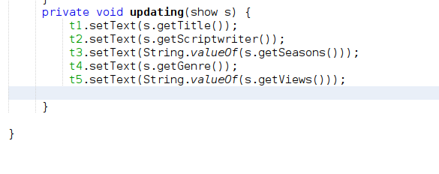

6.2. Instantiating the controller and the view.
We have the controller ready and we have made changes in the view, we are going to instantiate it appropriately, in the series.java, inside the main:
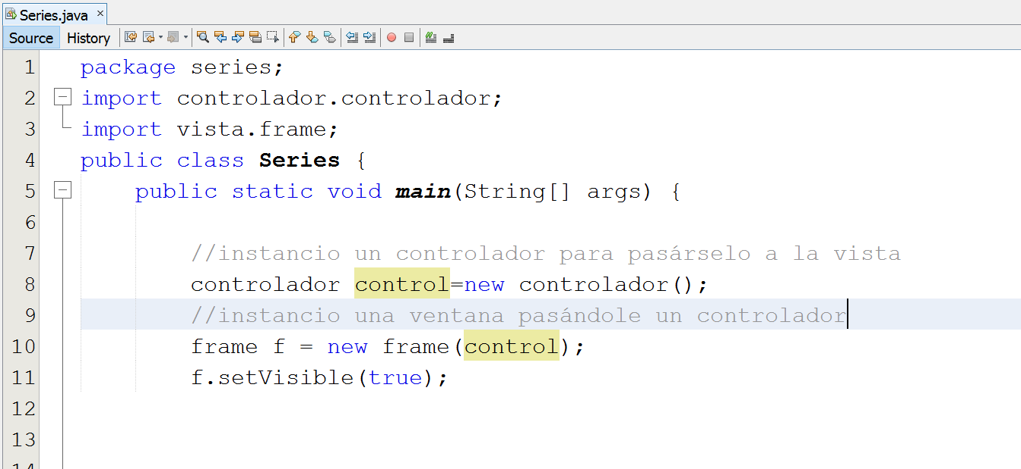
If we execute and click the button first (| <):
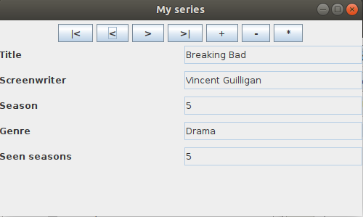

But the program is not finished yet, it is necessary to carry out the functionalities for the buttons: previous, next, last, new, delete and update. Let's go by parts.
7. Completing the previous and next functionalities.
In order to complete the previous and next functionalities, you will have to do two things: create the new methods in the model and call these methods from the listener.
7.1. Previous and next methods in the controller.
It will be something like:
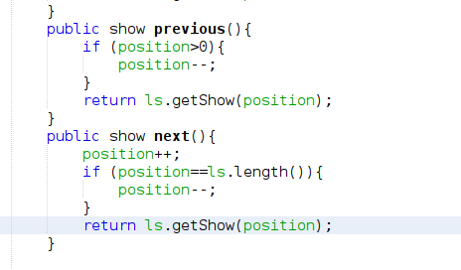

7.2. Calls from the listener of the frame class.
It would be enough with:
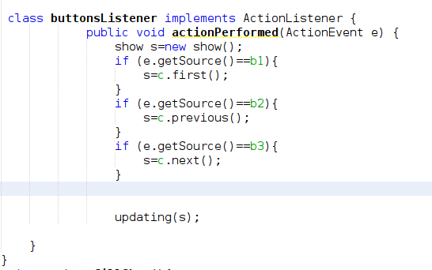

8. New functionality.
As in the previous cases, you must add code both in frame and in controller.
8.1 Changes in frame.
To create a new one, change the way of working a little. When a user clicks on the “+” again, proceed as follows:
1. All JTextFields are flushed so you can write the new string.
2. All buttons are disabled so that no other operation can be performed. In addition, the text of the button is changed from "+" to "+++" to emphasize to the user that she is in an operation.
3. The user writes the new string to the empty JTextFields. When you finish click the add button again, which now has the text of "+++"
4. As a result of that click: the new controller method is called, the buttons are re-enabled, and the text is set back to "+".
Therefore, in the case that the user clicks new, it will be necessary to see if he has done it for the first time or for the second time, we will add in the frame.java listener, a new if for the new button (b5):
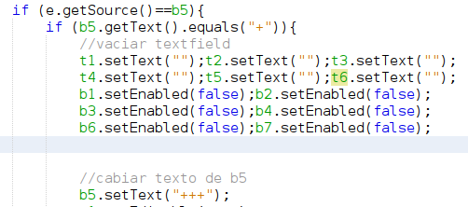

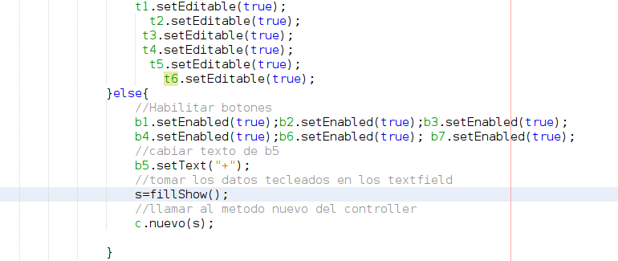

When the user clicks on the new button a second time, that is, on the else, the state of the buttons is first left as they were at the beginning. After the data that the user has written in an object of type show (series) is taken, we will use the method filledShow for it, and we call the new method of the controller passing it that object. We define the FillShow method after the listener and before updating, for example, leaving:

Fill show is a method in the frame that creates a show with the values from the texts:
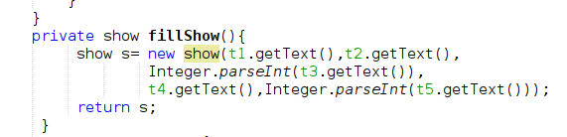

8.2. Controller changes.
In this case, the controller must perform two operations: add the new show object to the series arraylist, that is, ls, and save the ls in the file, since this operation involves modification of the data and thus we guarantee that they will be available in the file:
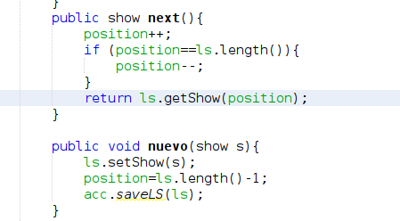

We test the new functionality, for this we run the project and first click once on the "+" button:
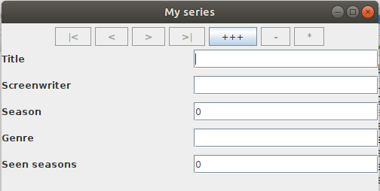

Now we write the data of a new series and we try the application:
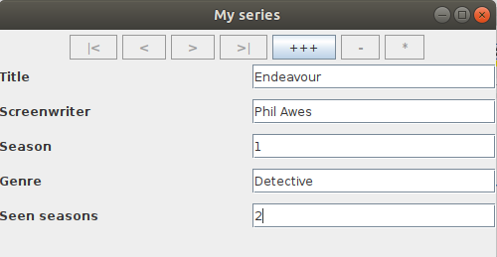

We press the "+++" button again, which is the only one possible:
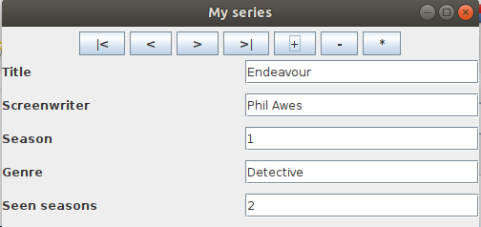

If we quit the program and run it again, we can verify that the new series continues to exist.

